ELEC 2210 Fall 2020

Lab 5 Quiz

Name: __________________________________



Section: _________________________________

1. What is the approximate voltage value at R when the switch in Figure 1 is open? What is the voltage when the switch is closed?

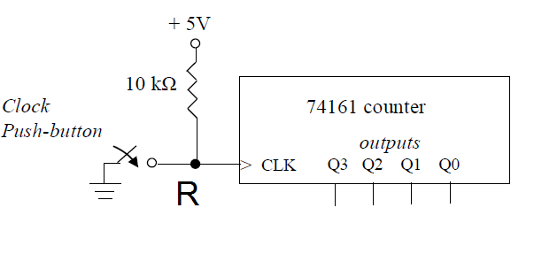

Figure 1: Switch Circuit

Open: VR = 0v

Closed: VR = 5v

1. For the cross-coupled NAND RS latch (R, S active low) shown in Figure 2, complete the truth table and identify what state (set, reset, hold, and indeterminate) the latch is in for each S and R value:

